**Ideation Phase**

**Define the Problem Statements**

|  |  |
| --- | --- |
| Date | 15 April 2025 |
| Team ID | SWTID1743603827 |
| Project Name | Book -Store |
| Maximum Marks | 2 Marks |

**Customer Problem Statement Template:**

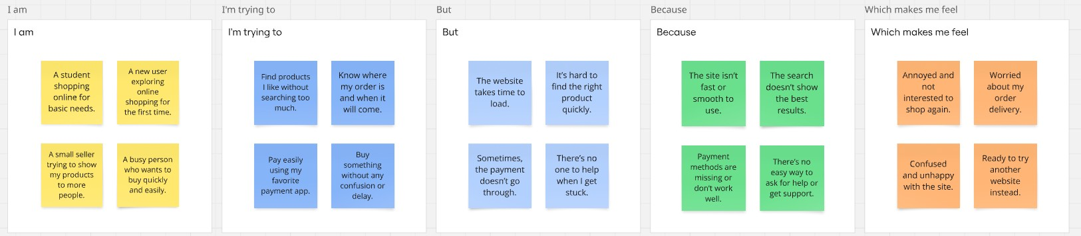

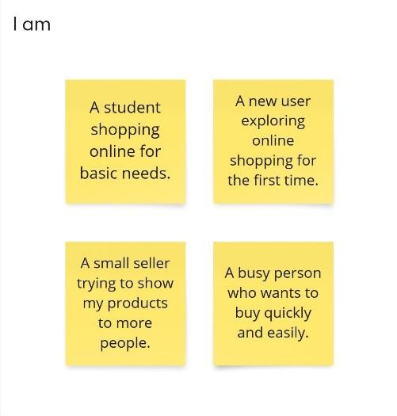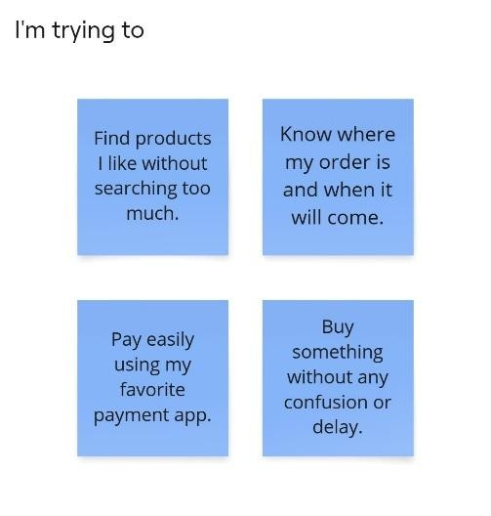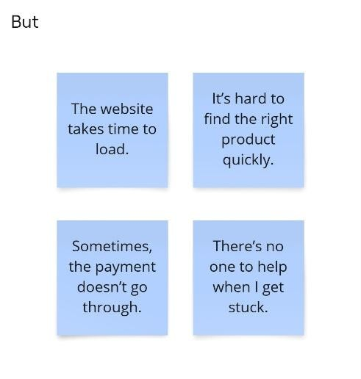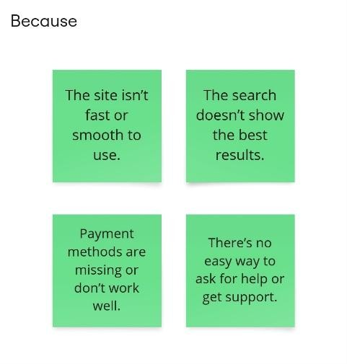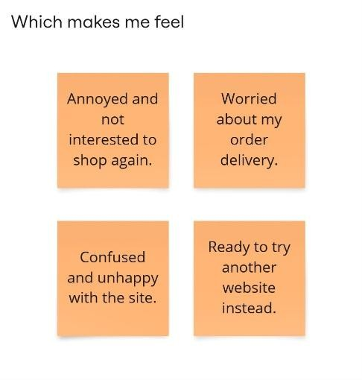

|  |  |  |  |  |  |
| --- | --- | --- | --- | --- | --- |
| **Problem**  **Statement**  **(PS)** | **I am**  **(Customer)** | **I’m trying to** | **But** | **Because** | **Which makes me feel** |
| PS-1 | An online shopper | Find products that match my preferences quickly | The recommendations are not accurate and often irrelevant | The system does not analyse my browsing history and purchase behaviour effectively | Frustrated and less likely to make a purchase |
| PS-2 | A busy professional | Checkout my order instantly without multiple steps | The process involves multiple  pages and form-  filling | There is no one-click checkout option available | Annoyed and discouraged from completing my purchase |
| PS-3 | A techsavvy user | Use voice search to find products efficiently | The platform does not support voiceenabled searches | Typing long product names is timeconsuming | Dissatisfied and looking for a more modern shopping experience |
| PS-4 | A furniture buyer | See how a product would look in my space before buying | There is no AR preview feature available | I want to make an informed purchase decision | Uncertain and hesitant to complete the purchase |
| PS-5 | A bargain hunter | Get notified about discounts on my saved items | I have to manually check for price drops | Automated alerts would help me purchase at the best price | Disappointed and might miss out on good deals |